Databases - Open Office. org Base

Author: Blagorodna Lazova
Subject: Informatics for II year
Topic: Databases
Level: High school
Language: Macedonian Language
Type of material: Electronic teaching material database
Material Format: Text document

Abstract: The term database means organized whole of interrelated data stored in one or more tables in the computer. Relational databases represent databases where data is possible to arrange them in terms of similarity. This document shows the creation of databases by creating tables as a basic element in a database. Shown is the creation of tables with all their elements and Edited them and later are created and forms, queries and reports.

Content:
1. BASIC CONCEPTS
2. CREATING RELATION DATABASE
3 CREATING TABLES IN DATABASE
4. CREATING AND WORKING WITH FORMS
5. CREATING OF QUESTIONS OR QUESTIONARE
6. CREATION OF REPORT

Databases – Open Office. org Base

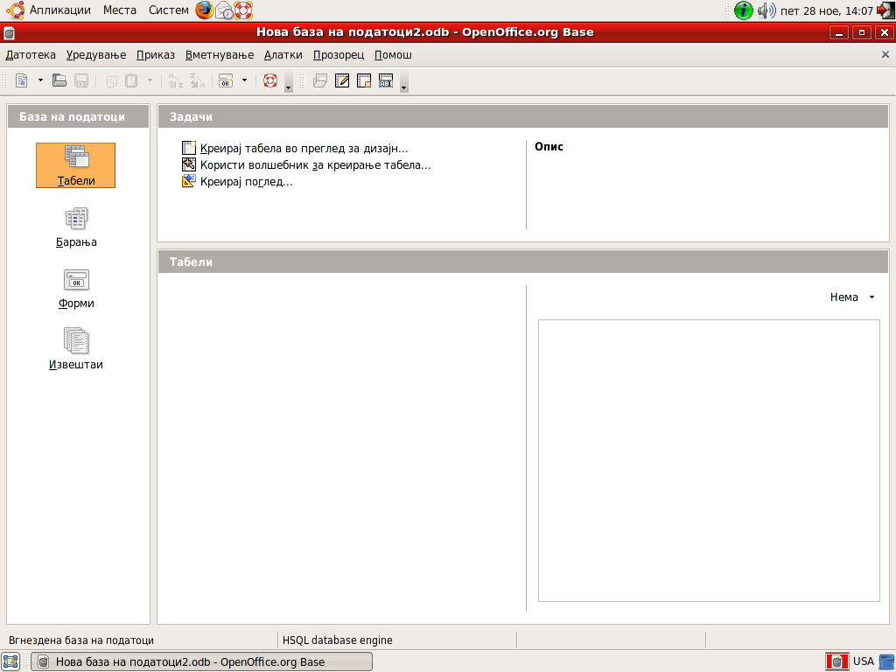

1. BASIC CONCEPTS
In a computer we can not store the actual items, but, again, the data describing the objects are stored in a digital recording.Hence, the term database
means an organized whole of interrelated data stored in one or more tables in the computer.
Relational databases represent databases where data is possible to arrange them in similarity of concepts in multiple tables, then tables to relate to each other and combine the data.

2. CREATING relational DATABASE
-Creating an empty database and its storage on the hard drive in a folder
-Creating tables in the database
-Definiranje fields and data types in the table
-Setting of the primary key and save the table
-Setting relationships between tables in the database
-Creating forms the basis
-Creating questionnaires base
-Creating reports based

The table is an essential element for organized storage of data within the database.In it record the data for persons or objects with similar properties
.
Tables represent the whole of rows and columns. One row in the table in the relational database is a record. Each column represents pole.Zapisot contains all information about the terms in the table, and column-box contains the same type of data.
In each table usually the first field is a field identification (ID) which is usually counter that automatically increases and actually count the rows (records) in the table. Field identification enables uniqueness of queues, is not be two identical rows.

New database you can create with:
1. Opening of application Open Office. org Base
2. When the application is already open, it may select File / New / Database.
3. Where the database will be ready last to do is preserve.

Elements database
Once you have created a base of a home is empty, the program opens the window of the database, which contains all the elements objects, menus and toolbars to work with the base.
Facilities in the database
To explain the functions of the basic facilities that are working in the database:

-Tables
-Applications
-Forms
-Reports

Tables are the main object in the database that stored data.The them later can be added or deleted data, but it is good they napochetok to design because of it depends on the functionality of the database and the ability to search data.
Requests or questions serve for finding, selecting and combining data from one or more tables.For at the same time, allow combining and joining multiple tables in a new one. Issues of all data as separate and only those showing only those required by a set criterion.
Forms are windows that create a visually more visible entry and access fields from multiple tables that are connected to formata.Toa actually a graphical interface between us and the base.
The forms can be edited in different patterns to form as well as buttons in shape, but the effects can be placed in text format and more.

3.CREATING TABLES IN DATABASE
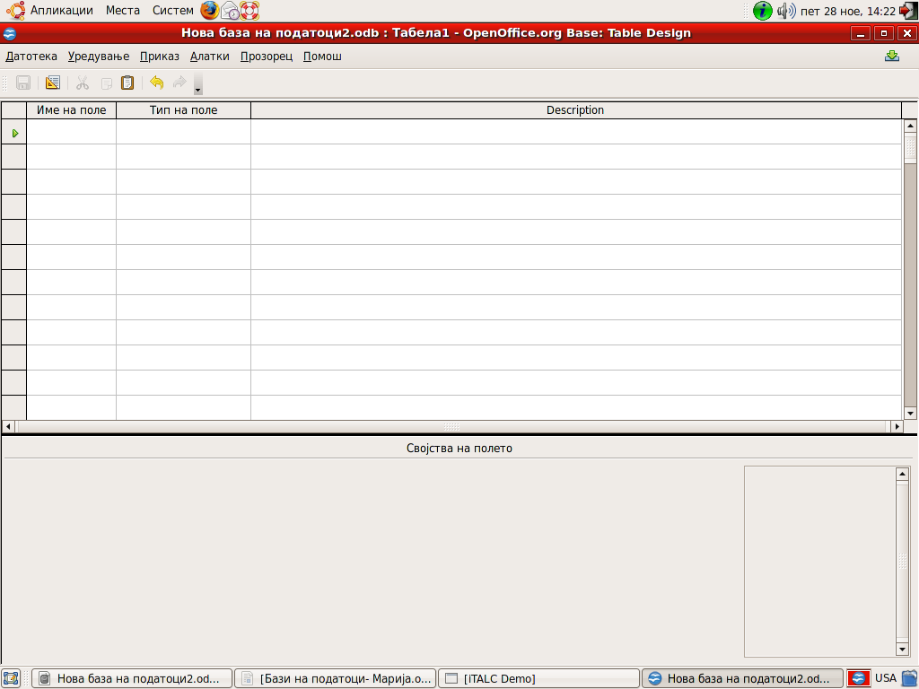

To create a table of the first buildings on the basis choose Tables, and then offered opportunities
Tasks window you choose Create Table in Design view, after which opens a window for creating a table.
The upper part of the window is divided into three columns.
Name of field-where, the name of the field that can contain letters, numbers, but usually sets the short name or abbreviations, which are explained in the section Description.
Type field-define what type of data will contain the field and is selected from the list, which appears automatically in any order.
Field properties-can be defined by three data: field name, format data and description.

The optimal size of the field in the database used for the rational use of memory.

Typical data fields

Tables can be imported different types of data from text, numbers in different formats record, pictures, dates, time and so on. In the second column in the creation of tables, automatically enter a list of types of podatociod we choose an appropriate data type that you enter in the first field (Name field). Commonly used types of fields:
1. Integer (Integer) - integer, which automatically increases with each input record (row), if Avtomat.vrednost property is set to YES.
2. Number (Numeric) -only number.
3. Decimal (Decimal) - integer where the part Properties at the bottom of the window, you can set the number of decimal places.
4. Text (Varchar) - plain text that can be a letter, number, symbol.
5. Yes / No (Boolean) - logical operator, which has two values, Yes or No, which sets mark in the field.
6. Date (Date) -datum which the properties of the field can determine which format will be written.
7. Time (Time) -time also can set the format of time-outs, the section Field properties.
For all types of data that are selected from the list in the section Properties enables changing certain properties or formats the display of different types of data.

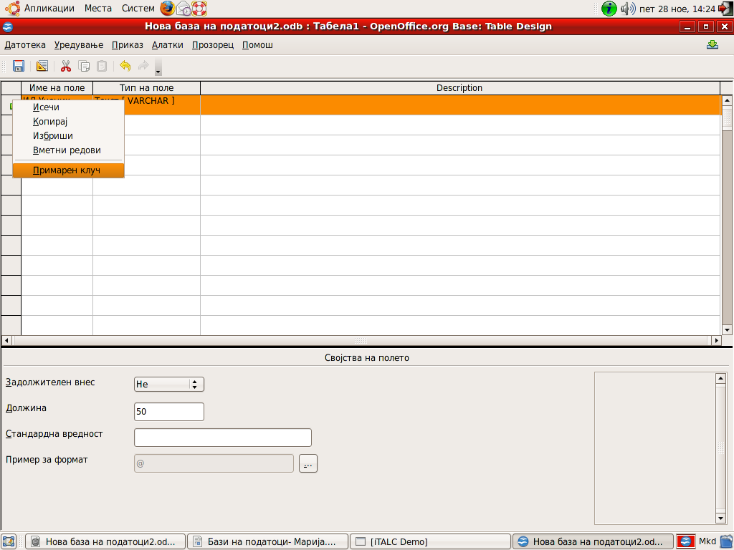
Primary key
The advantage of relational databases over regular tables is that the relational database entries in the tables are unique and no repeat of the row (record) with exactly the same data in all polinja.Podatocite differ in at least one pole.Za to hold it , tables first field is usually an identification field to the table and it sets the primary key.
Its purpose is to determine zapisite.Toj is usually Integer Avtom.vrednost whose status is set to YES, which avotmatski increases with each new input record and practically count the rows and records in a table.
This key is placed in the design of the plate, with selection of field (usually the first field) or by right-clicking the drop-down menu is selected Primary key. After uploading noticeable sign key field.

Save the table
After naming the fields and setting the table's primary key should be preserved through the File / Save As .. and in the dialog box to set the table name.
Closing a table
The table can close in two ways:
1 with the standard method of X
2. The menu File / Close
Opening spreadsheet editing
We mentioned that the tables can also ureduvaat.Toa and we can achieve by opening the database, select the object tables in the window which lists all tables tabelata.Potoa select menu Edit / Edit or by right-clicking on the table and from the drop down menu select mode device after we open the table for editing in design view.
Deleting fields
To delete fields, first selktira number and then right-click pravoagolnicheto front row you want to delete from the drop down menu, choose Delete or Edit / Delete.
Adding fields
The fields are added in correspondence at the end of the table, you can also right click, front row, then from the drop down menu we choose option Paste rows, and this option sets the cursor to the end of the already written lines.

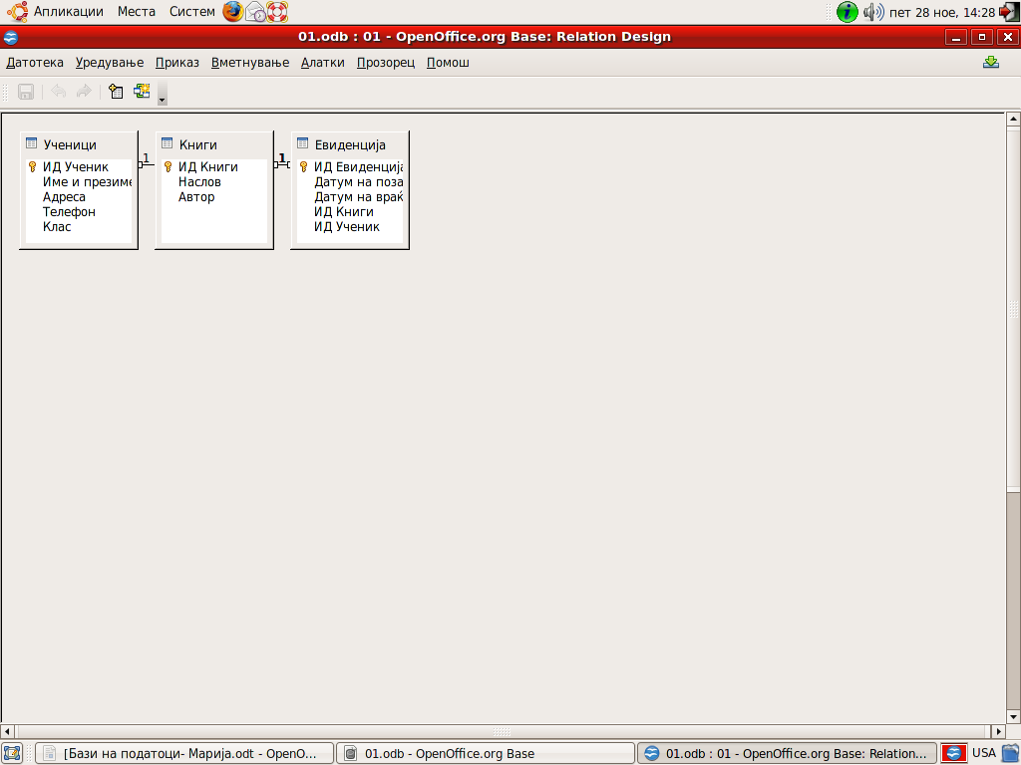
Relations betveen tables

1Adding tables
Tables should be co
nnected to set relations between them and then you can combine data from multiple tables. It is necessary in the window of the base to open the window from the Tools menu relations / Relations.
It is then added to the tables, we want to connect it, and we choose the window Adding tables, which usually opens to include into the Insert / Upload tabeli.Od it then selects the first table, for example, books, click Add the table and thus be entered in the window Relacii.potoa add second pupils and so add all consecutive tables in the window of the relations that should merge with the relationship.
2.Connection tables
The most common relationships between tables: one to one and one to many.
Relation to one more particular about the relation between tables Books & Loan
It means that the title of a book can be found in several rows in the table Loan.
This is normal because of one title may have the same 10 books and can lend more students and it can be written many times in the table Loan.
Setting the relationships expressed by fields connection.
Relations are used to connect the columns between tables.
3. Editing of relations
To delete a route, the line of the route click right click and select Izbrishi.Za to edit route click Edit, which opens a dialog box where you need to include options previously marked to be updated tables in the relationship, in case of a change in the very tables.
4. Search data
Very easily through the database to search the default data. Opens the chart in which you want to search klik.Potoa double clicks in right where to find the data and select the option Find entry toolbar. In the window that opens Request recording inserts text data to be searchable.
5. Filtering data
Filtering data using data when the crowd we only those under a given kriterium.Za to filter data first opening our database then double-click opens the table from which you want to use the data at the end of the toolbar, click the Filter option when we are opening a new prozorec.Vo it sets the condition for filtering ie our request after which should be separated from other data.
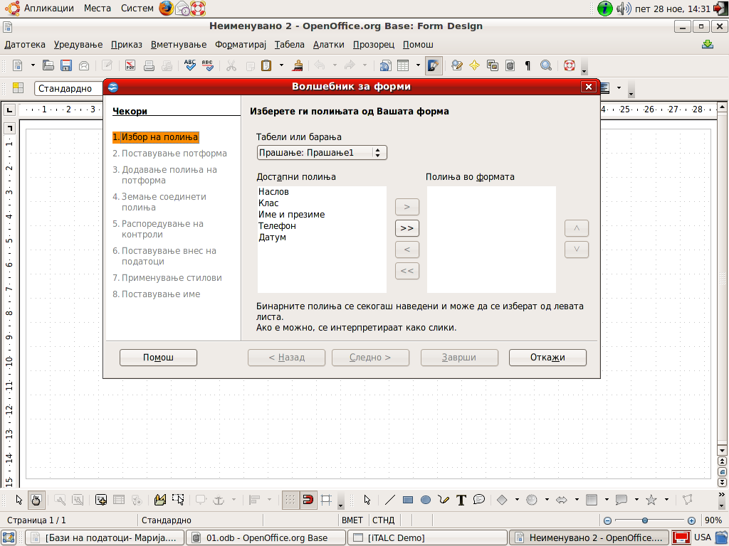
4. CREATING AND WORKING WITH FORMS

Entering data directly into tables can sometimes be difficult, especially when you need to input data into multiple tables and should each be individually opened. For this purpose we easier to use objects from the database, ie use format.
Through forms can enter data automatically in one or more tables simultaneously and can be selected in fields that will be entered podatoci.Formite can be created in design-view, but also through a simpler way using the wizard.
1. Entering data through form
The form first opens double-click the name of the form or right-click the form names and Otvori.Potoa click in the first field and entered podatok.Niz fields can move with TAB. By entering the data, the same Veda saved so you do not need additional storage of data, while the data of the form can be deleted by pressing the delete by simultaneously deletes the record from the source table.
2. Edit form
Once you create a form that can also be edited at will and potreba.So right click on the form from the drop down menu or selects Edit menu Edit / Edit.
Controls are all elements that can be inserted into the form, such as fields, text notes, lists, check boxes etc. confirmation.
3. Create a list field
Fields lists are used to facilitate data entry that are repeated. To not be registered repeatedly, can again be defined in the list and then just choose it.
4. Change the type of control
Once you set the control in the form may change its type. To change the type of control of the field in the field list.
5. CREATING OF QUESTIONS OR QUESTIONARE

Request a way as any information we learn from the database. When creating the application, it can combine data from multiple tables or by other requirements.
The request shall contain only those fields needed for a given application, which can be placed in a different order from those in the table. Not all fields can be included.
It is a kind of filtering and sorting data, with the ability to set multiple conditions simultaneously.
1.Creating of request
-First in claim select Left panel
-potoa the right Tasks choose Create issue in view of the design for themselves to set the required fields issue
-dodavanje tables or issue we choose tables and questions that we need for a given application with selekvija the name of the table and the Add
-are condition for the application in order criterion and after
-baranjeto saved via File / Save.
Tables see which fields will be visible in the application
Alias ​​is the name under which the field will be displayed in the application, while the field is kriteruim condition is set and that the data is filtered by the other and filter only those.
In criterion can be set relational operators <,>, <= or> = that filter data from fields.
In criterion data is recorded in quotes "".
Example: If you just put '' in the criteria it means to display all entries found empty fields

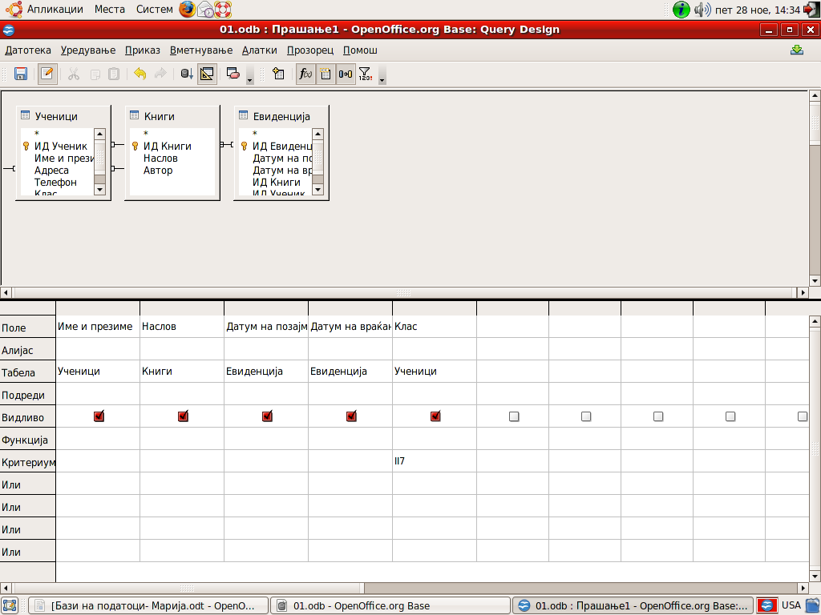

2.Activating ofrequest
Once we created the application, you should look at the results we have achieved with baranjeto.Baranjeto to be activated, which is done by opening the application, double-click the name or right-click the name, then Open.
The result shows only data that we have zadadile with the requirement in the request.
If later the table still bring some data, then when re-opening the application to get new results.
Alias ​​is the name under which the field will be displayed in the application, while the field is kriteruim condition is set and that the data is filtered by the other and filter only those.
In criterion can be set relational operators <,>, <= or> = that filter data fields
6.CREATING OF REPORT
Reports are objects in which data is organized and grouped in that you can add additional text fields, logos, images so they are prepared for final printing.
They can be created from fields to tables or requirements.Such and all other objects in the database and they can then create and edit.
1.Creating report wizard
-The panel database is selected Reports, then the panel Tasks Use wizard to create reports.
-are defined fields that will contain the report and can be selected from a table or query by transferring the right side of the window
-in the second step is choosing the titles of fields clearer in some areas that we have set as shortcuts in tables
-potoa doing grouping the data, which will appear in the report
-potoa results can be sorted
-are determined the design and orientation of the paper
-the end application preserves the standard way and click on Finish.

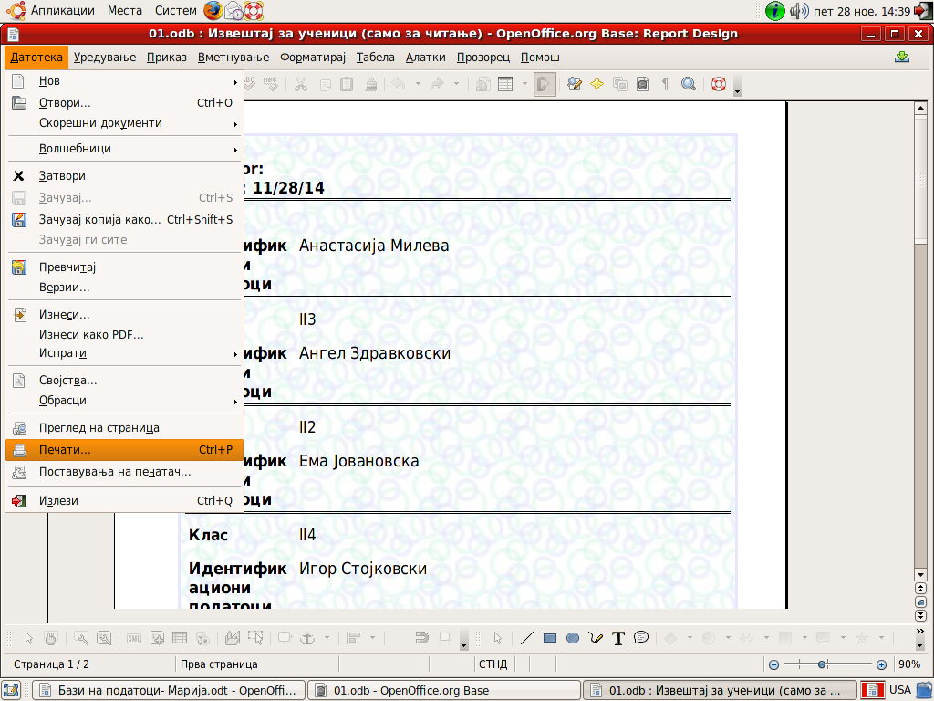

2.Printing report
If we are satisfied with the report then we can pechatime.Za printing exercise the option File / Print, which is then followed Print window where you can define standard options for printing copies, orientation leaf sl.Za fast printing use Print option from the toolbar file directly.

